Cornucopia Game

Response to a training need

I was working half-time for myself as a web application security consultant and half-time for Blackfoot (a UK risk and infosec consultancy) who had a lot of clients who were subject to the Payment Card Industry Data Security Standard (PCIDSS) issued by the PCI Security Standards Council (https://www.pcisecuritystandards.org/). PCIDSS requires that developers are trained and apply security knowledge to avoid vulnerabilities in the parts of their systems in-scope for PCIDSS, such as web front ends that take card payments. In summer 2012, I was asked to provide web application security training to a group of developers who were heavily into agile methods. The sessions were arranged for two separate groups, one on a Monday morning and another on the Tuesday morning. Each session was going to be about three hours or so, so I knew there would be a high risk of boredom, fatigue and people switching off during the training. I had seen MS-SDL EoP but struggled to apply it myself to website applications. I decided to create a more web appsec focused version, and with my knowledge of many OWASP projects, homed in on the Secure Programming Practices Quick Reference Guide (SCPQRG) as a source for the attacks. I wanted the game to be closely associated with PCIDSS to suit my upcoming training, and thus put “Ecommerce” in its name. I imagined that other decks might be made for other types of web applications, or other application software, and thus called this one “edition” of many. Recently I had been reading Charles Stross' novel Singularity Sky (https://en.wikipedia.org/wiki/Singularity_Sky) which had described “cornucopia machines” with the ability to produce a multitude of “things”. In the same way, the card game would span an abundance of attacks and webapp vulnerabilities, so using the “horn of plenty” concept (https://en.wikipedia.org/wiki/Cornucopia), I chose the name “Cornucopia”.

MS-SDL EoP was open source and had published source Adobe InDesign files, but I did not have and could not afford an Adobe licence and had never used Adobe software. So in my own time and with a budget of £20, I created a Word document containing the cards laid out in a way they could be printed onto pre-scored/perforated business card blanks - the sort of A4 sheets you can buy from office stationery suppliers. I printed the cards on my own inkjet printer for the training sessions. As a contributor to other OWASP projects, I decided to make it an open source OWASP asset. I had some discussions with Keith Turpin, OWASP SCPQRG from 9 Aug 2012 and published the document called "OWASP Cornucopia - Ecommerce Website Edition" version 0.3 as a file on the OWASP wiki, and sent an email to announce it to the SCPQRG mailing list on 15 August 2012 using the subject “SCP and the draft OWASP Cornucopia” (see Appendix). That announcement also alludes to how Cornucopia might also lead to a(n ecommerce) company's increased prosperity, through good appsec, and presumably a lack of fines and other costs associated with PCIDSS failures.

From nothing to something

I am not sure of the training session dates, but believe they were during the week following this announcement, w.c. Monday 20 August 2012. Despite the self-printed cards, the game was well received during the training. Otherwise there was little interest following my announcement to the single mailing list but in February, as part of keeping up-to-date with legislation and standards which might affect web apps, I found that Cornucopia had been mentioned in a newly updated PCIDSS guidance document: “Information supplement PCI DSS E-commerce Guidelines v2” released on 31 January 2013 (https://listings.pcisecuritystandards.org/pdfs/PCI_DSS_v2_eCommerce_Guidelines.pdf).

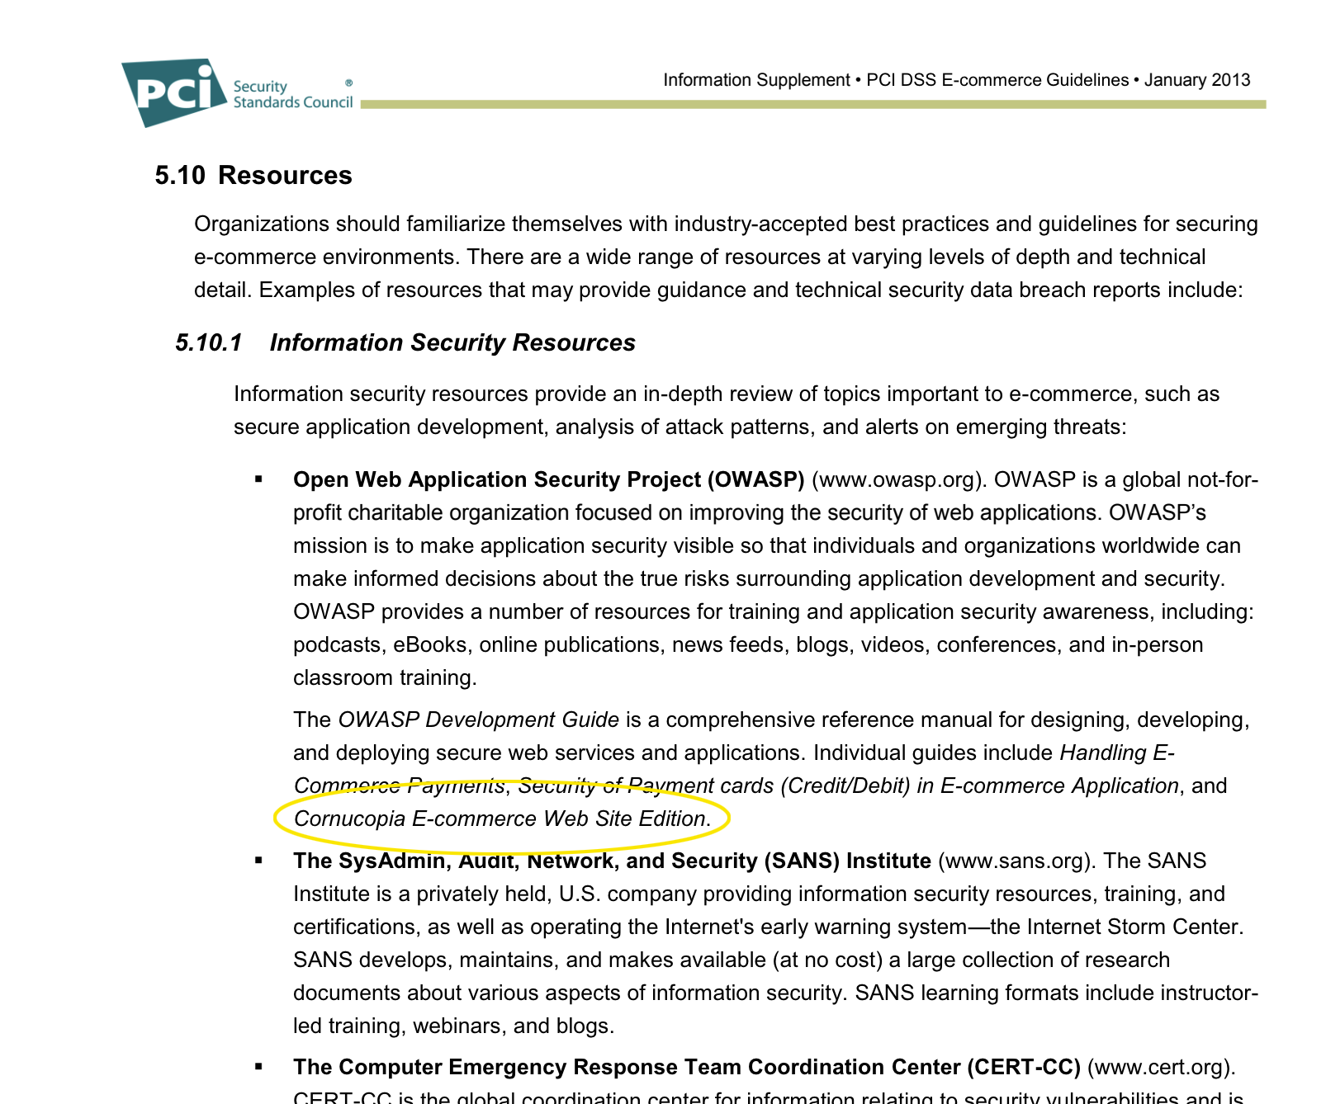

I don't know how Cornucopia was identified because it was simply a file referred to by one mailing list email, but if you searched the OWASP wiki for “ecommerce” it was in the few results. I notified the OWASP community about this by sending a message to the SCPQRG mailing list on 1 February 2013 (see Appendix).

That changed everything. I decided that v0.3 needed to be converted into its own OWASP project, mentioning this in another email to the SCPQRG mailing list on 21 February 2013 (see Appendix). I created v1.0 and published it on 25 February 2013 (see history https://wiki.owasp.org/index.php/File:OWASP-Cornucopia-Ecommerce_Website.docx) and submitted a “new project request' to OWASP the same day, with this completed on 5 March. I worked on the wiki (https://wiki.owasp.org/index.php/OWASP_Cornucopia) in April and May 2013, announced to the new Cornucopia mailing list on 18 May 2013. A short presentation about Cornucopia was provided on 3 June 3rd 2013 at OWASP London chapter's event for the OWASP EU Tour 2013. Conference (presentation https://wiki.owasp.org/images/8/8f/Owasplondon-colinwatson-cornucopia.odp).
Printed decks

OWASP projects had no budgets at the time, and there were no resources to get the game printed or create print-ready design files.

In September 2013 Blackfoot, who I was still working for half-time, offered to print decks of cards to give away free of charge, and donate the design files to OWASP so that others could use them. I insisted Blackfoot's branding did not appear on the cards, and there would be no OWASP branding on Blackfoot's packaging (their card boxes). Blackfoot gave me decks in December 2013 and made them available on request worldwide, to anyone who contacted them. This did cause a lot of grief from a small number of people in OWASP. However, it was the first step in making adoption and use much more widespread, and I was able to give away hundreds of decks at various OWASP chapter meetings, OWASP training and other events.

Eventually Tom Brennan, an OWASP board member, found funding to print card decks in an OWASP branded box in summer 2014, and give them away to attendees at AppSec USA 2014. The remaining stock and subsequent batches were available to order from OWASP for a number of years and were very popular.

Wiki deck

Darío De Filippis became involved in OWASP Cornucopia in September 2015, eventually becoming a co-leader of the project. Dario conceived and created, and published on 21 January 2016, the "Card Deck Wiki" for the Ecommerce Website Edition, with each card having a unique URL.
Appendix – Announcement and Follow-Ups on the OWASP SCPQRG Mailing List

SCP and the draft "OWASP Cornucopia"
Cornucopia

Colin Watson <colin.watson@owasp.org>
Wed, 15 Aug 2012, 21:44
to owasp-secure-coding-practices

SCP list

Threats, attacks and security requirements
--------------------------------------

I am a fan of Microsoft's Escalation of Privilege (EoP) threat
modelling card game (published as
http://creativecommons.org/licenses/by/3.0/us/ ), and find that a very
useful tool for developers, including those using Agile methods.

http://www.microsoft.com/security/sdl/adopt/eop.aspx
http://blogs.msdn.com/b/sdl/archive/2010/03/02/announcing-elevation-of-privilege-the-threat-modeling-game.aspx

But I wanted something a bit more specific for the more common web
applications, and which fits more closely with OWASP advice and
guides. I therefore thought it should be based upon the OWASP Secure
Coding Practices - Quick Reference Guide (SCP). So I have created
"OWASP Cornucopia - Ecommerce Web Application Edition" which largely
has the same concepts and game rules as EoP. I also wanted to avoid
too much jargon and especially using the term "threat modelling" too
much. Think "identifying security requirements" instead.

Rather than being a separate project, I thought this could be a
complementary document, or promotional item, for the SCP project.

I hope another version could be "OWASP Cornucopia - Mobile App
Edition", and that would need some rework to cover the OWASP Mobile
Project's work. Why "Cornucopia"? I was looking for a name of the
sixth suit and didn't want "miscellaneous" or "other". In EoP, one
suit is called the same as the game (Elevation of Privilege), so I
thought we could do something similar. Cornucopia gives an abundance
of information, and hopefully leads to a prosperous company.

Cornucopia
--------------------------------------

Cornucopia tries to condense most of SCP requirements into 6 suits,
and this has meant some merging of requirements. The suits are:

- Data validation and encoding
- Authentication
- Session management
- Authorization
- Cryptography
- Cornucopia (everything else)

Each suit contains 13 cards, and there are two extra Jokers (unlike
EoP). But like EoP the Aces are "you have invented a new XXX attack",
leaving 12 cards in each suit. This means some/many cards include more
than one SCP requirement. The descriptions still have to be phrased as
an attack but I wasn't keen on beginning every description with "An
attacker can...", wanting something more engaging, and therefore used
personal names. These can be thought of as external or internal people
or aliases for computer systems. I also wanted to reflect the OWASP
community aspect, so apart from "Alice and Bob", I use the given
(first) names of current and recent OWASP employees and Board members
(assigned in no order), and then randomly selected the remaining 50 or
so names from the current list of paying individual OWASP members. No
name was used more than once, and where people had provided two
personal names, I dropped one part to try to ensure no-one can be
easily identified. No names were allocated specifically to any
particular attack/defence/requirement. The cultural and gender mix
simply reflects theses sources of names, and is not meant to be
world-representative.

To make the cards semi-universally available, I have created them in
MS Word and laid them out so they can be printed onto Avery business
card sheets (85x54mm,10/page). That's currently A4 sheets, so I don't
know how it works on old-world paper sizes. Ideally it would be nice
to create some proper print-ready designs, since digital printing onto
proper playing cards won't be much more expensive, and could be a lot
cheaper, than the Avery card option. A cheap version can be created by
printing onto plain paper and slicing them up.

More information in the source Word document (see below).

Look-ups
--------------------------------------

But I also wanted to try to cross-reference the descriptions on the
cards with other lists, so they also act as pointers to more-detailed
resources, and so far have included:

- ASVS for Web Applications 2009 verification IDs
- AppSensor detection points
- CAPEC IDs (still working on this, because there must be a CAPEC for
every attack)
- SAFECode security-focused stories in "Practical Security Stories and
Security Tasks for Agile Development Environments"

I didn't map to any Top X lists since those change over time, and they
can be derived from the above anyway. I had intended to list CWE IDs,
but there would be too many for some, and there are mappings from
CAPEC and the SAFECode items to CWEs which can be used instead. I have
mapped the cards to the SCP, just numbering the requirements from 1 to
213. The numbers are meaningless other than being an ID. In a new SCP
edition some numbers might be deleted and new ones (e.g. above 120)
added. So the ordering of the numbering has no meaning and there are
no section names. These could be mapped to any future common numbering
schema.

These mappings need to be reviewed, and shouldn't be considered
definitive. The following items are mapped to any cards:

- ASVS V1(all), V7.9, V8.7, V8.11, V9.6, V12.2, V12.4, V14(all)
- SCP 82, 97-98, 100, 106, 116, 120, 141, 163-166, 184-188, 193, 202

I can provide the SCP IDs in an amended version of SCP v2 to anyone
interested, but didn't want to confuse others by posting it onto the
wiki.

Special cards
--------------------------------------

The Ace and Joker cards do not have cross-references, so include
pointers to some other OWASP resources:

- many of the cheat sheets
- the 4 guides
- individual membership
- Broken Web App VM and Hacking Lab

Download
--------------------------------------

v0.3 is at:

https://www.owasp.org/index.php/File:OWASP-Cornucopia-Ecommerce_Website.docx

What next?
--------------------------------------

At the moment, this has been a sole effort apart from using other
people's ideas (credits in the document). I am trialling these cards
out, but would welcome feedback, corrections and improvements.

- Are the attack statements worded correctly?
- Does the game work?
- Are there any duplicates in the attacks?
- Are any attacks weak (why have some no CAPEC reference?)
- Is the grammar correct and consistent?
- Have I manged to use "international English" correctly?
- Will the text make sense when translated into other languages?
- Are the mappings correct (any CAPEC, ASVS experts out there?)

Regards

Colin

Colin Watson <colin.watson@owasp.org>
Fri, 1 Feb 2013, 13:41
to owasp-secure-coding-practices

Interestingly this game has been mentioned in the updated PCISSC's
information supplement on PCI DSS E-commerce Guidelines released
yesterday. See 5.10.1:

https://www.pcisecuritystandards.org/pdfs/PCI_DSS_v2_eCommerce_Guidelines.pdf

By extension then, it references the OWASP Secure Coding Practices
Quick Reference Guide.

I'd like to extend the documentation on Cornucopia, and give guidance
on reduced card-decks if you are using a framework that can/could
provide certain security controls, probably referencing this excellent
document:

OWASP Framework Security Matrix
https://www.owasp.org/index.php/Category:Framework_Security_Matrix

Colin

Keith Turpin <>
Mon, 11 Feb 2013, 17:05
to me

Wow that is great. I am glad the game is catching on.

The framework matrix is a great idea and a much needed project.

_______________________________________________
Owasp-secure-coding-practices mailing list
Owasp-secure-coding-practices@lists.owasp.org
https://lists.owasp.org/mailman/listinfo/owasp-secure-coding-practices

--

Keith Turpin
OWASP Project Leader
...

[Message clipped] View entire message

Colin Watson <colin.watson@owasp.org>
Thu, 21 Feb 2013, 09:58
to Keith

Keith

> The framework matrix is a great idea and a much needed project.

I am thinking of converting this into its own OWASP project, so it can
have its own review and releases.

Colin

---------------------------------------------

